GenAI QTrac – Agentic Architecture Document

1. Overview
GenAI QTrac is an agentic GenAI platform that converts natural‑language data quality (DQ) requirements into validated BigQuery SQL rules. The solution is deployed on Google Cloud Vertex AI and implemented using Google Agent Development Kit (ADK), enabling modular, governed, and scalable multi‑agent orchestration.
The architecture follows an agent-first design with strong validation, explainability, and continuous learning.

2. Reference Architecture Diagram (Overview)
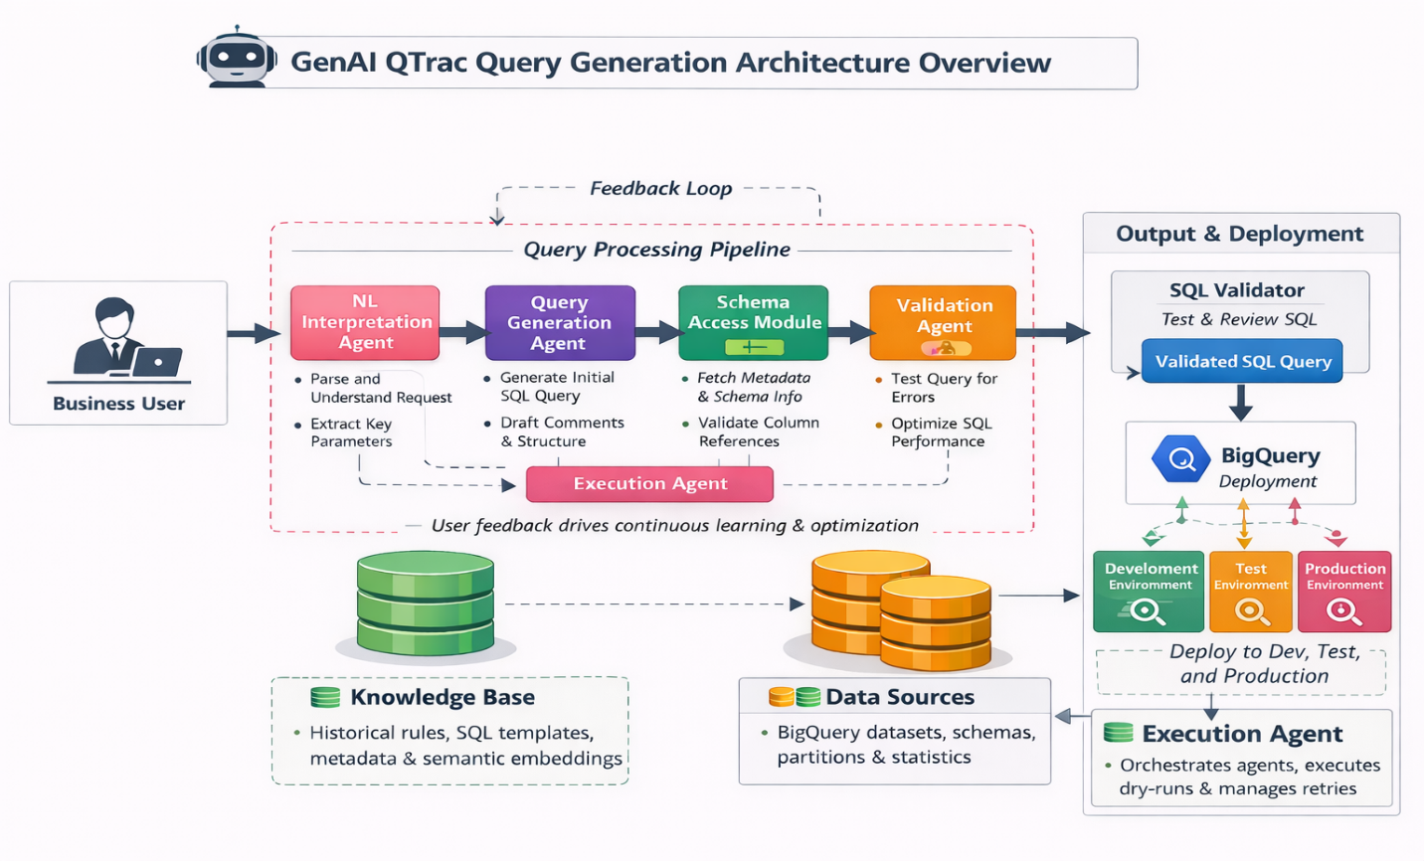
Diagram: GenAI QTrac Query Generation Architecture Overview
The diagram illustrates: - Business user interaction - Agentic query processing pipeline - Knowledge Base & Data Sources - Execution orchestration and feedback loop - BigQuery deployment across Dev / Test / Production environments

3. Platform & Technology Stack

Cloud Platform
- Google Cloud Platform (GCP)

AI & Agent Framework
- Vertex AI
  - LLM access (Gemini / approved models)
  - Embeddings generation
  - Vector search (Vertex AI Matching Engine)
- Google Agent Development Kit (ADK)
  - Agent lifecycle management
  - Tool invocation
  - Inter-agent communication

Data & Analytics
- BigQuery (Dev / Test / Prod)
- Cloud Storage (artifacts, logs)

Backend & APIs
- FastAPI / Cloud Run (or GKE)
- IAM, Cloud Logging, Cloud Monitoring

4. High-Level Architecture Layers
- User Interface Layer
- Agentic Query Processing Layer
- Knowledge Base & RAG Layer
- Execution & Validation Layer
- Deployment & Feedback Layer

5. Agentic Query Processing Pipeline (Core)
This pipeline is implemented as cooperating agents using Google ADK.

5.1 NL Interpretation Agent
Purpose: Understand business intent from natural language input.
Key Tasks: - Parse and understand the user request - Identify rule intent (null check, threshold, freshness, etc.) - Extract key parameters (tables, columns, filters, time windows)
Outputs: - Structured intent object (JSON) - Complexity classification (simple vs complex)

5.2 Query Generation Agent
Purpose: Generate initial SQL logic.
Key Tasks: - Generate SQL using templates (preferred path) - Invoke LLM via Vertex AI for complex logic - Add comments and logical structure to SQL
Implementation Notes: - Uses RAG context from Knowledge Base - Uses Gemini / approved LLMs on Vertex AI

5.3 Schema Access Module (Agent Tool)
Purpose: Ensure schema-aware SQL generation.
Key Tasks: - Fetch BigQuery table & column metadata - Validate column references and data types - Resolve joins and relationships
Data Source: - BigQuery INFORMATION_SCHEMA

5.4 Validation Agent
Purpose: Guarantee correctness and performance.
Key Tasks: - Perform SQL syntax validation - Execute BigQuery dry-run - Optimize query for partitions & performance
Outputs: - Validation status - Estimated query cost

5.5 Execution Agent (Orchestrator)
Purpose: Coordinate the entire agent workflow.
Key Tasks: - Orchestrate agent execution sequence - Manage retries and fallbacks (template → LLM) - Trigger BigQuery dry-runs and capture results
Why it Matters: This agent turns individual agents into a resilient, production-grade system rather than a linear prompt chain.

6. Knowledge Base (RAG Layer)
The Knowledge Base grounds the system with domain context.

Contents
- Historical DQ rules (business ↔ SQL mappings)
- Approved SQL templates
- Business metadata and definitions
- Vector embeddings of past rules
- Data governance documentation

Usage
- Semantic retrieval using Vertex AI Matching Engine
- Context injection into Query Generation Agent

7. Data Sources

Primary Data Source
- BigQuery Data Warehouse

Contents
- Datasets and tables
- Column metadata & data types
- Partitioning & clustering info
- Basic table statistics

Purpose
- Ensure schema-valid SQL
- Improve performance and cost efficiency

8. Output & Deployment Flow

SQL Validator Output
- Fully validated SQL query
- Cost and performance metrics

BigQuery Deployment Environments
- Development Environment
  - Initial testing and experimentation
- Test Environment
  - Integration and UAT validation
- Production Environment
  - Approved, governed DQ rules
Deployment is controlled via: - IAM & approvals - Environment-specific datasets

9. Feedback Loop (Continuous Learning)

Feedback Sources
- User approval / rejection
- Manual SQL edits
- Query validation failures
- Performance metrics

How Feedback Is Used
- Update vector embeddings
- Improve templates
- Refine agent prompts
- Enable future fine-tuning on Vertex AI
Outcome: Accuracy improves over time with reduced LLM cost.

10. Security & Governance
- IAM-based access control
- Human-in-the-loop approvals
- Full audit logs
- Environment isolation (Dev/Test/Prod)

11. Key Benefits
- Agentic architecture ensures reliability
- RAG minimizes hallucinations
- Vertex AI provides enterprise scalability
- Google ADK enables modular agent evolution
- Strong governance for regulated environments

12. Future Enhancements
- Fine-tuned domain LLM on Vertex AI
- Auto-discovery of new SQL templates
- Multi-warehouse support
- Rule impact simulation dashboards

Platform: Vertex AI
Framework: Google Agent Development Kit (ADK)

